

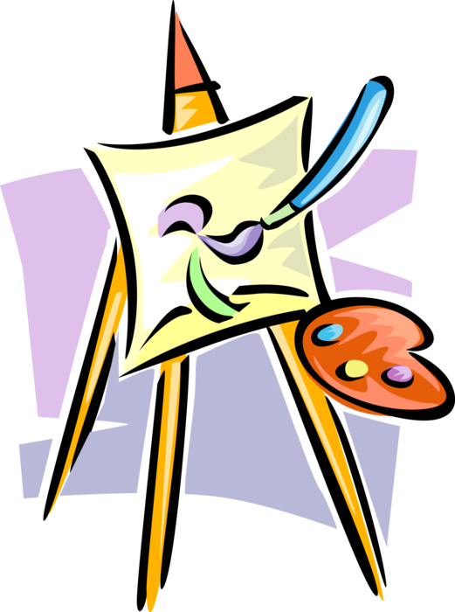
15-16 August 2026
COBRAM LIONS CLUB
ART SHOW
2026

KILLARA HOUSE
SHOWGROUNDS BANKS St COBRAM
TWO SECTIONS:
10-14 YEARS
OPEN 15+
Entries Close 9 AUGUST 2026
Phone Cobram Lions on 0459 340 109 for Details and Topics

