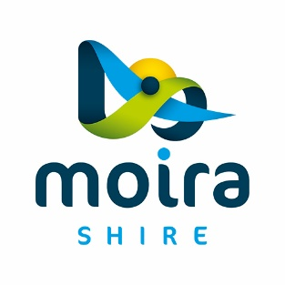

LEXUS MELBOURNE CUP
COBRAM
Monday 6 October 2025
Breakfast at Thompson’s Beach  6.30 to 10.00 am  Early morning opportunity to see the cup and take photos  Egg and Bacon Rolls for sale  Free Tea and Coffee  Games for Children  Free Entry  Stop by on your way to work or school | 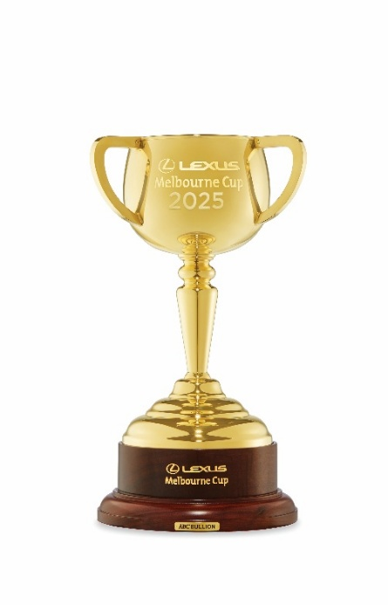 | Gala Dinner  Grand Central Hotel  Commences 5pm allowing  Photo opportunities with the Cup  Includes a delicious  2 Course Meal  Drinks @ Bar Prices  Tickets @ $100 per head  Dress Code : Smart casual  Bookings  https://www.trybooking.com/DETFY  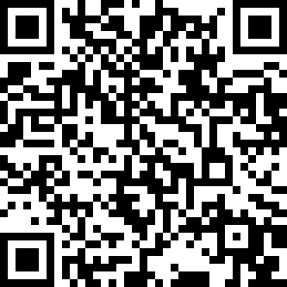

Come and meet a Jockey, See the Cup and Join the festivities.
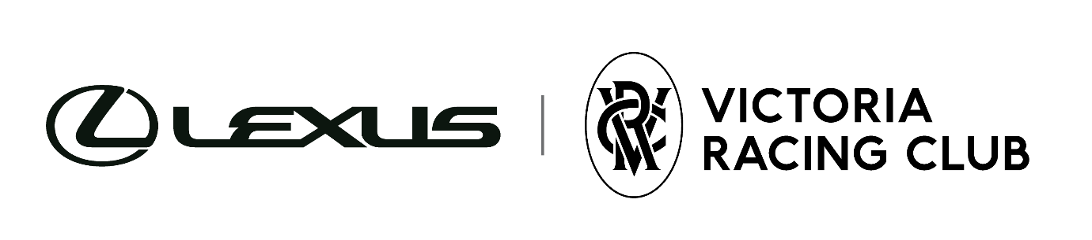
Money raised goes to NCN Health Cobram to provide access to dialysis services for Cobram / Barooga locals.

