[](http://www.google.com.au/url?sa=i&rct=j&q=&esrc=s&source=images&cd=&cad=rja&uact=8&ved=2ahUKEwirnOu9_uLeAhVFdCsKHUHjDXQQjRx6BAgBEAU&url=http://clipart-library.com/lions-club-logo.html&psig=AOvVaw2RyT6tcFvlwTEFYR2kTRVB&ust=1542803882959968)

**Cobram Lions Club**

**Log Cabin Community**

**Market**

**Saturday 27th September. 2025.**

Federation Park, Punt Road, COBRAM

8am till 1pm.

***Welcome to the Spring Market***.

A massive variety of stalls. Something for everyone.

A great market to explore.

Have Breakfast or Brunch with the Lions members.

Phone 0459 340 109 for all market inquires.

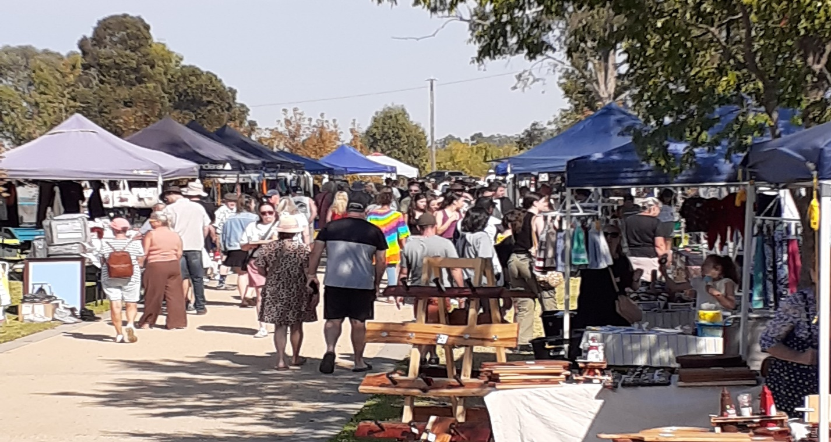

Follow Cobram Lions on Facebook for all Updates.